------------------------------------------------------------------

// to write a "hello" using h1 tag in the html page

<body>

<div id="root">

<h1>hello</h1>

</div>

------------------------------------------------------------------

// to write a "hello" using h1 tag in the html page using JavaScript

<body>

<div id="root"></div>

<script>

// target a node where we have to appear element

const root = document.getElementById("root");

// create html tag usig JS function "createElement(<tag>)"

const heading = document.createElement("h1");

// inserting the text inside that created tag

heading.innerText = "heelo"

// using appendChiled method adding up this created element in target node

root.appendChild(heading)

</script>

</body>

------------------------------------------------------------------

// to write a "hello" using h1 tag in the html page using React

--after importing React from cdn --

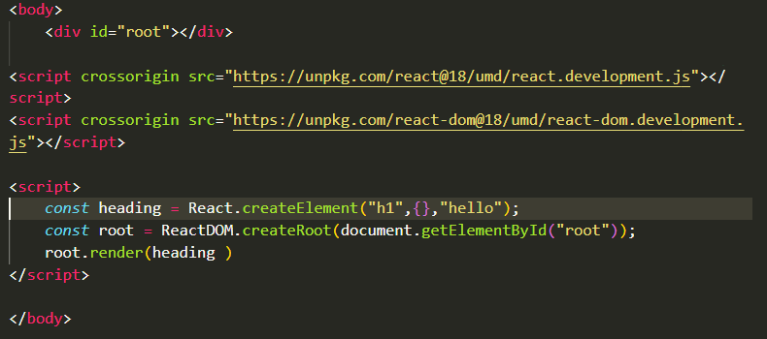

// "createElement method of react takes 3 para- tag, empty object, and Inn erText"

// when we needed to set class or id for that created element then we put it inside that empty object, in a key-value form 

// using ReactDOM we do specify the entry point of react into our html page

//That is how react got to know where it have to render rest of the code

// "render()" is used to render the created elem at the root node

------------------------------------------------------------------

// to create nested elements

We have to write like that

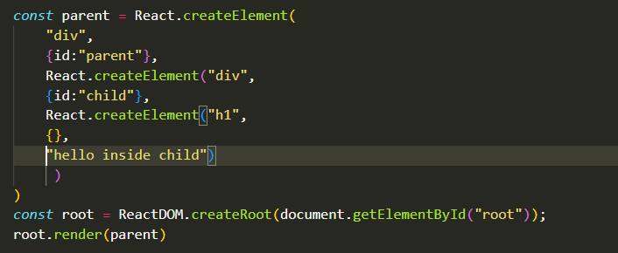

o/p🡪

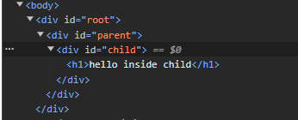

// to create siblings inside nested

